

OPEN-SOURCE CODING

Part 1



April 24, 2023

VARSITY COLLEGE

LECTURER: EBRAHIM ADAM & SARINA TILL

RESEARCH

The three Time Tracking applications that our group will be analyzing are Clockify, TimeCamp and Toggl Track. The respective applications are popular amongst users that use the Android operating system, time tracking applications allow us to monitor certain productivity that is going on within our daily lives which can be utilize for our own personal use and it benefits us as individuals to record tasks that need to be carried out and help us organize and prioritize better.

**Clockify**

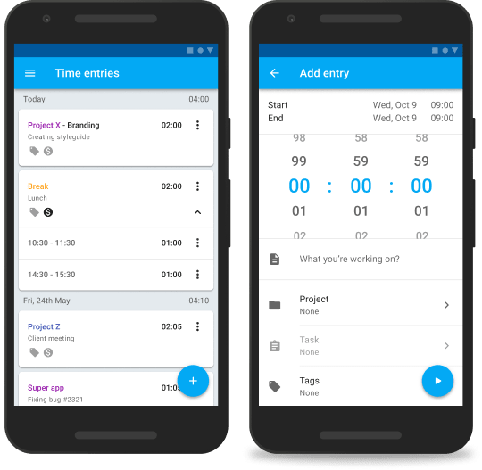

Clockify is a popular time tracking application used widely among android users. It has a variety of unique features that may seem a bit too advance for some users but its many strengths overshadow its weaknesses. GetApp(2021) states that “Clockify is provided for unlimited users, projects and clients where you can measure employee productivity, track progress of every project and do all the administration and reporting work in a single place.”

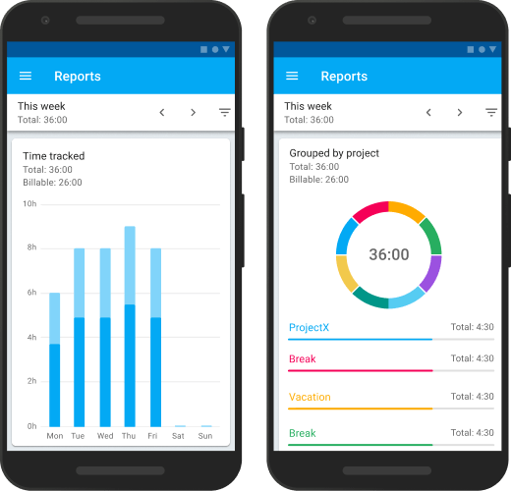

**Strengths**

* Free subscription plan is offered to users along with the basic features needed to satisfy an individual needing to track their time.
* The application has a user-friendly interface that makes it easy to navigate and use.
* A detailed report is provided which allows users to give a brief overview of their time spent on a certain task or project.
* This mobile application can be used amongst Android or IOS users.

**Weaknesses**

* The free plan offered does not allow features which include team management and advanced reporting as those features are only available on the paid subscription plan.
* There have been reports to the slow response time when contacting the customer support team when a user comes across an issue within the application.
* When an individual is wanting to observe an employee’s activity or have a look at the work been done within a specific period of hours that were tracked, the application does not allow automatic screenshots.
* Customization of the application is limited hence a user can find it frustrating to not be able to customize their project and task labels.

**Innovative Features**

An AI is used to detect when a user starts or stops working on a task which maximizes the efficiency of the application. Clockify allows users to collaborate with team members working on a specific project as well as allow users to set budgets which ensures that projects are completed within the budget and time frame set.

***Toggl Track***

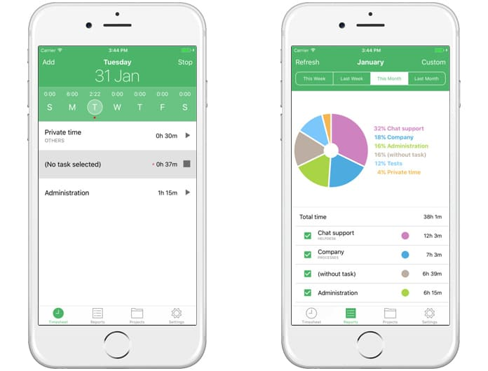

Toggl is a flexible time tracking application in which allows individuals to keep track of their personal hours, task and projects whether you’re in a team of many members or just be yourself.

**Strengths**

* Its user interface displays a friendly clean and easy to navigate through appearance.
* The application lets users track time on different projects or task and contains a feature used for categorization with allows individuals to add notes and tags.
* Toggl has tools in which can be used which are Google calendar and Asana which enables you to break down large work into manageable tasks.
* Detailed reports are provided within the application for the user.
* There are many pricing plans as well as a free plan which offers basic feature for users who are low on budget.

**Weaknesses**

* The free plan offers limited feature and does not include team management and advanced reporting.
* Application lacks customization hence task labels and project customization are limited.
* Poor response times is an issue when it comes to contacting the support team when users encounter a problem.
* Toggl does not offer automatic screenshots when an individual is wanting to observe an employee’s activity or have a look at the work been done within a specific period of hours that were tracked.

**Innovative Features**

There is a feature in which allows individuals using the application to work in 25-minute interval with a 5-minute break in-between, the individuals are then more focused and productive during the course of the day. Toggl has a timeline feature that allows users to see a visual representation of the daily entries that they have entered, there is also a time tracking reminder that is used to make sure users track their tasks more efficiently and accurately.

**TimeCamp**

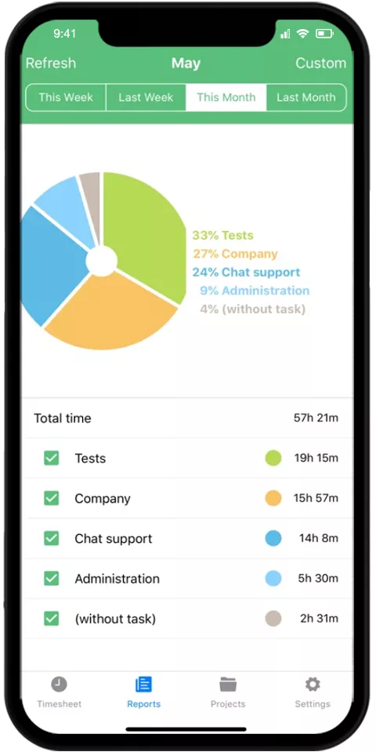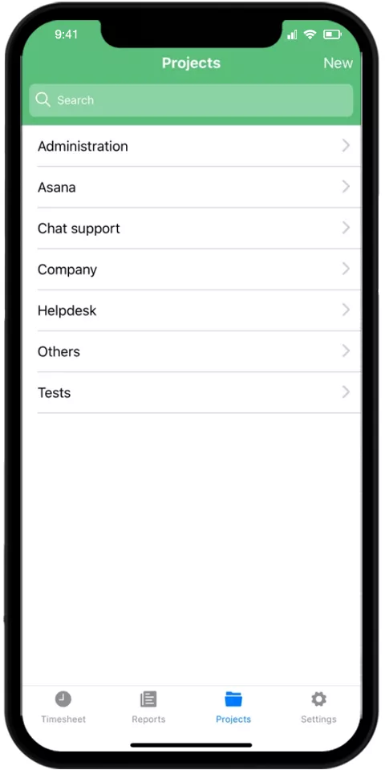

TimeCamp is a time tracking application that allows teams or individuals to track their tasks or projects. GetApp(2021) states that “TimeCamp is a provides individuals with a comprehensive yet user-friendly project time tracking solution.”

**Strengths**

* Automatic time tracking is offered which allows users to save time and help them to center their focus on the work they are currently doing.
* TimeCamp also has tools such as Asana which enables you to break down large work into manageable tasks and Trello.
* TimeCamp is available for both Android and IOS mobile devices.
* Different pricing plan is offered as well as a free plan for individuals who are low on a budget.

**Weaknesses**

* Free plan has limited features and advanced reporting and team management is only available in the paid plan.
* Customer support is limited as response times are slow.
* There are features within the application that can be too advanced for some users.
* The application does not allow automatic screenshot when it comes to an individual monitoring an employee’s activity or making sure work has been done within a period of time.
* The application is not customizable enough hence customization of projects and labeling of tasks is limited.

**Innovative Features**

TimeCamp have templates available that individuals can use for their projects which saves time. The workload management feature allows individuals to see how much work they have to do throughout the day that assists them in avoiding overworking. Invoices are generated to make it easy to bill the work done for clients.

Referencing

Website: Time Doctor. *Clockify review* [online] Available at: <https://www.timedoctor.com/blog/clockify-review/> [Accessed on 23 April 2023]

Website: Trust Radius. *TimeCamp* [online] Available at: <https://www.trustradius.com/products/timecamp/reviews?qs=pros-and-cons#reviews> [Accessed on 23 April 2023]

Website: Trust Radius. *Toggl* [online] Available at: <https://www.trustradius.com/products/toggl/reviews?qs=pros-and-cons#reviews> [Accessed on 23 April]

Website: CustomerThink. Top must have features of a progressive Web App [online] Available at: <https://customerthink.com/top-must-have-features-of-a-progressive-web-app/> [Accessed on 23 April 2023]